EC2 linux hardening script:
Step 1: Create an EC2 instance and connect to it.
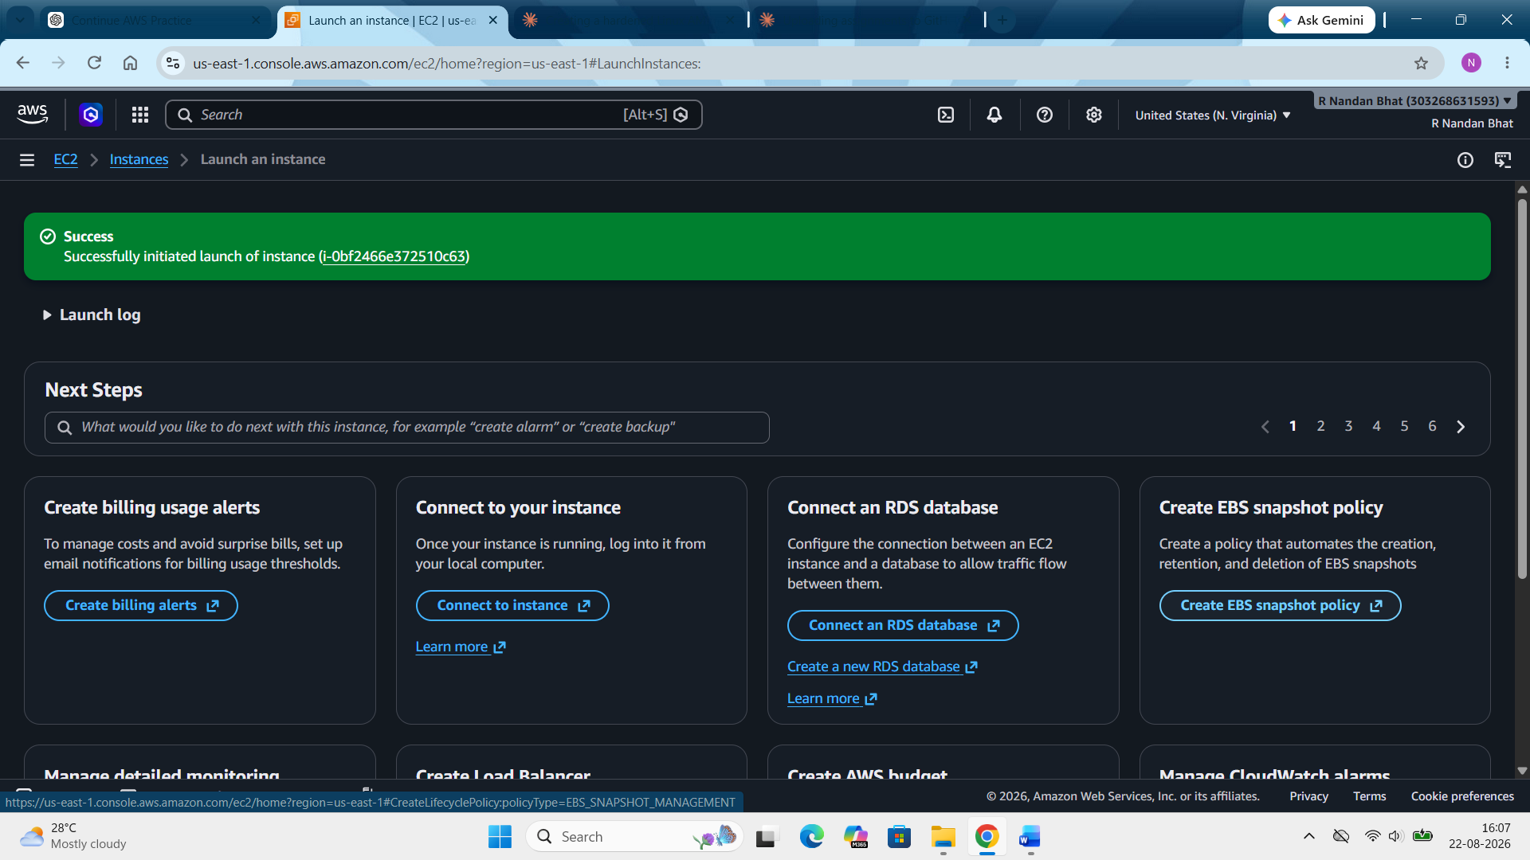
Step 2: Now we have to get the hardening script onto the server. Create a file in the server and place the script in it. Use vi command to write or copy the script and save it.
Step 3: Now run the script. If it doesn’t have the execution permission the enable it. chmod +x ec2-hardening.sh
sudo ./ec2-hardening.sh
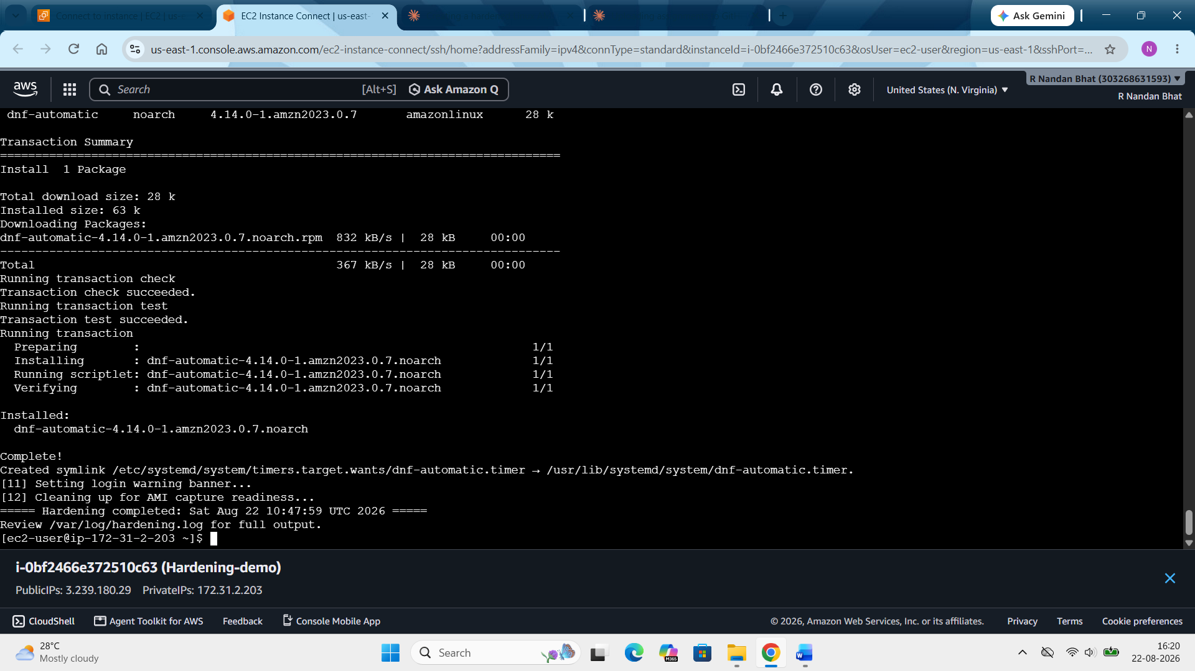
Step 4: Now that the hardening is completed, we will check if it works. Use the commands below to do that.
Check if the firewall is on: sudo systemctl status firewalld
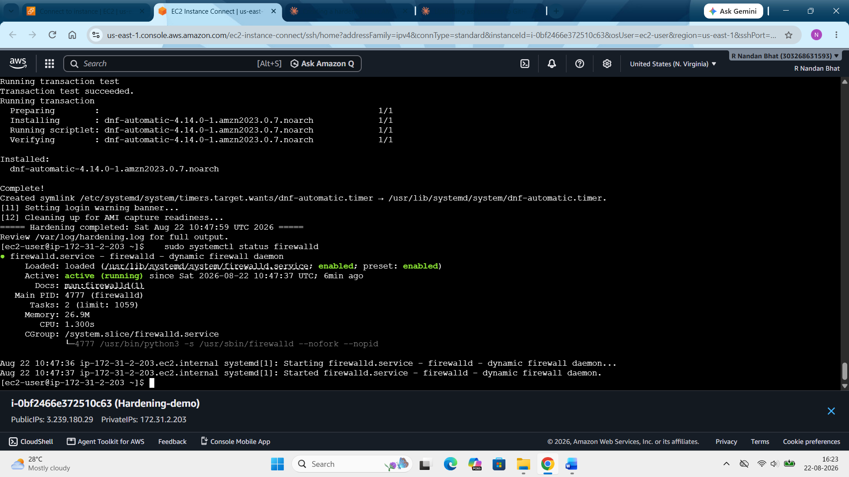
Check if the fail2ban is running: sudo systemctl status fail2ban
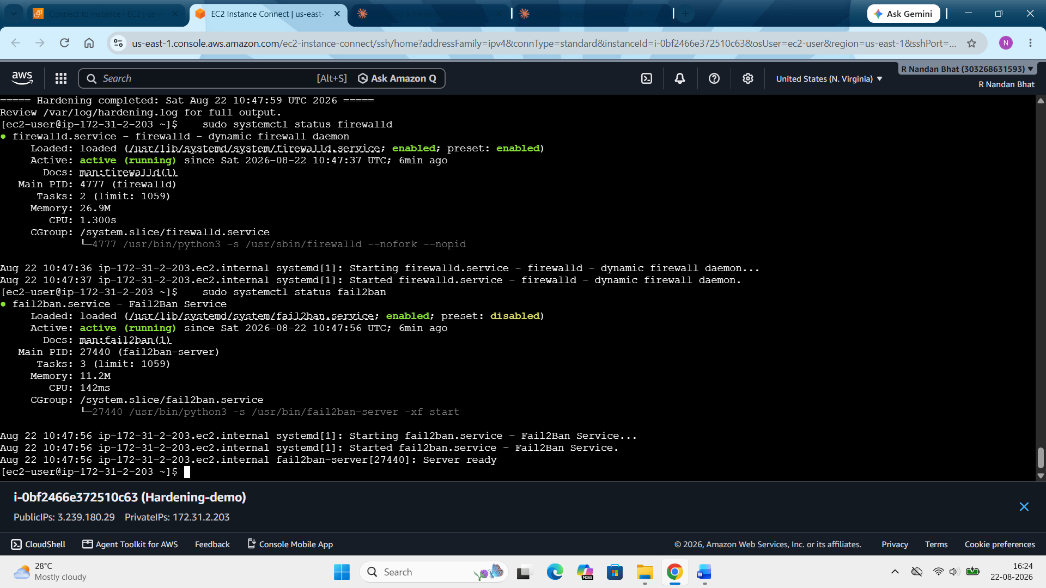

Check SSH root login is disabled: sudo sshd -T | grep permitrootlogin
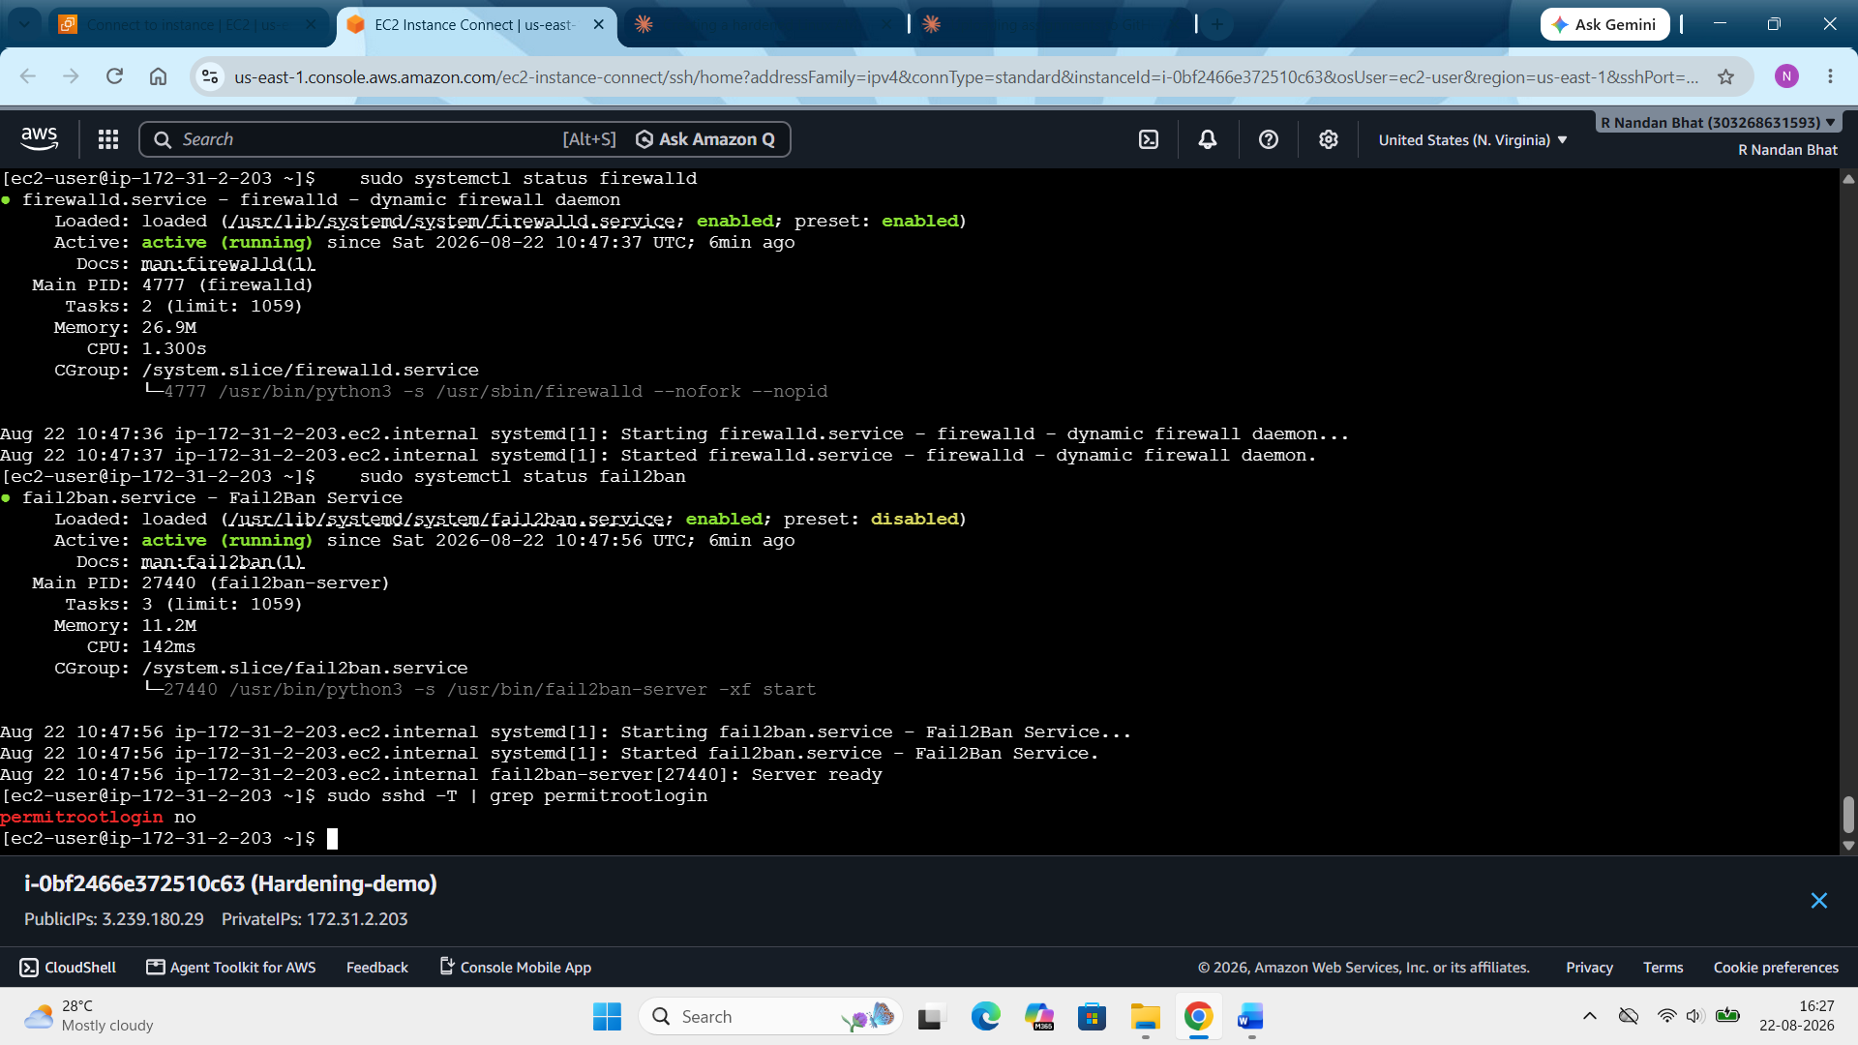
Check system auditing is running: sudo systemctl status auditd
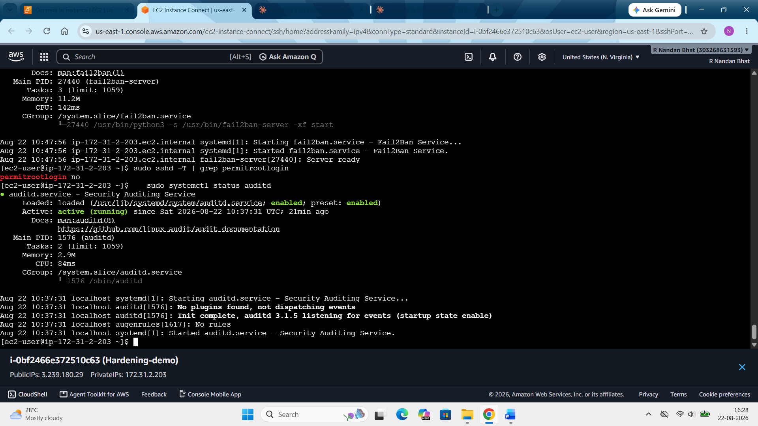

Full hardening log: sudo cat /var/log/hardening.log
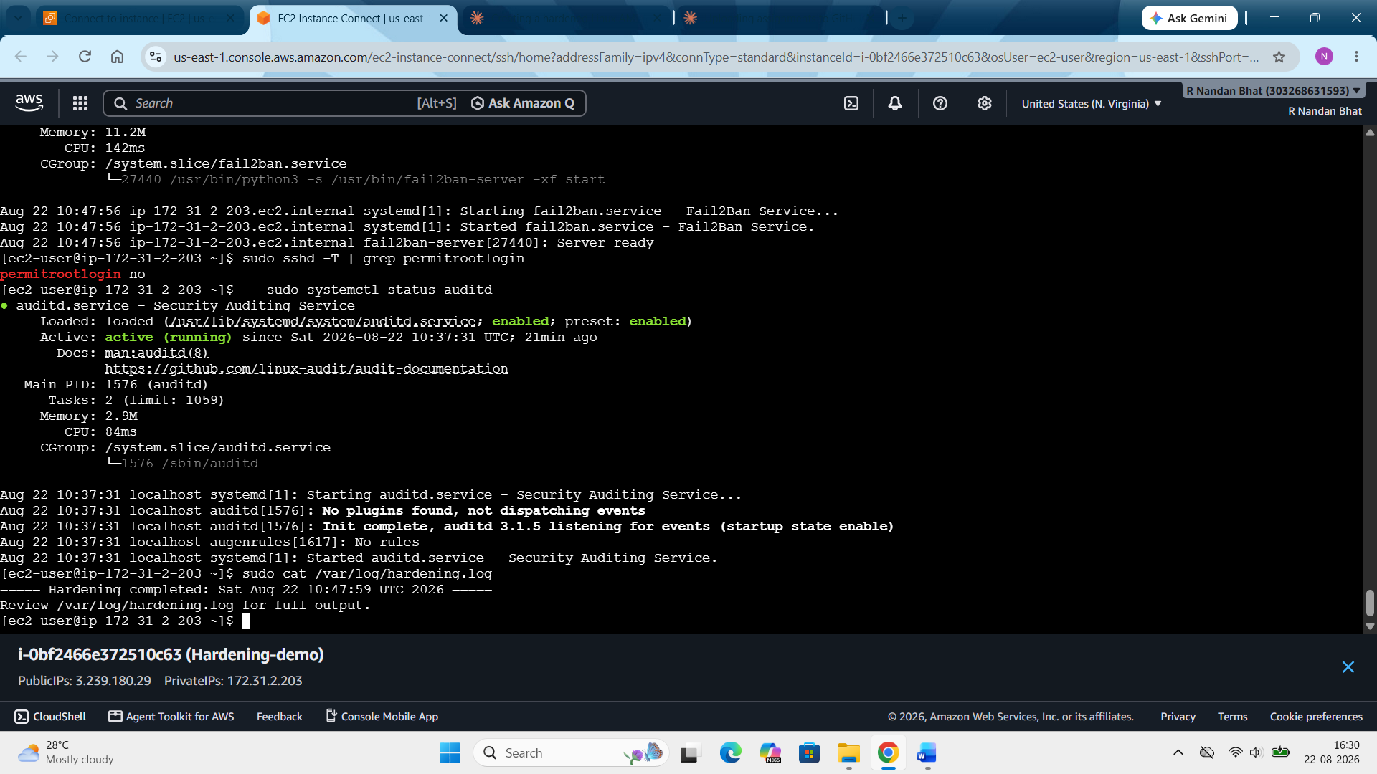
With this we can say that the server is properly hardened.
Step 5: Now the part where we will turn it into a reusable golden AMI. For that go to your instance and click action image & template create image.
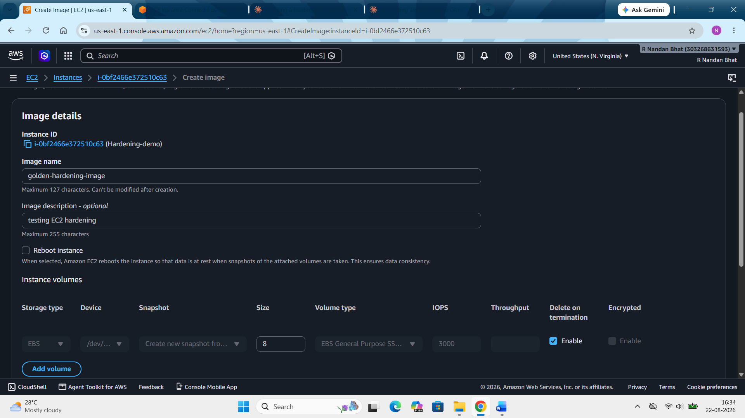

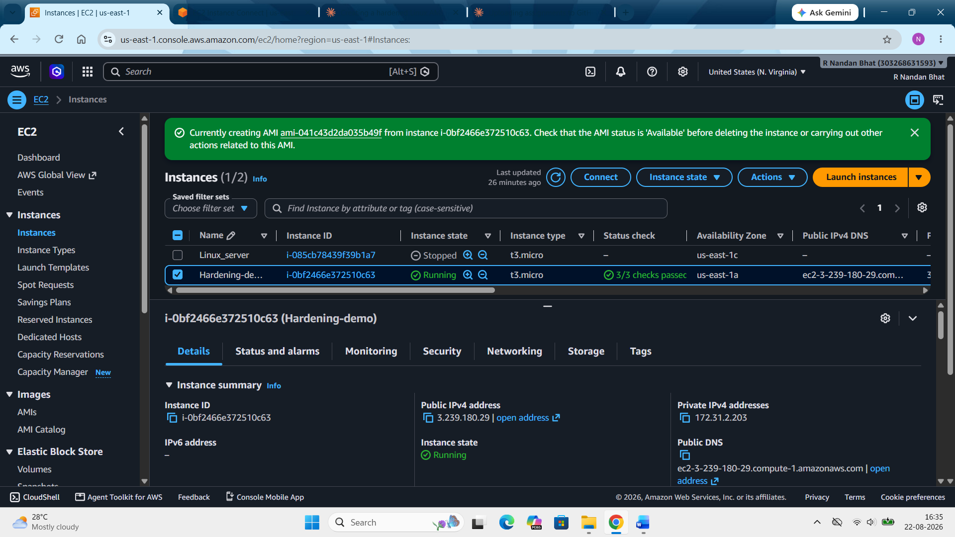
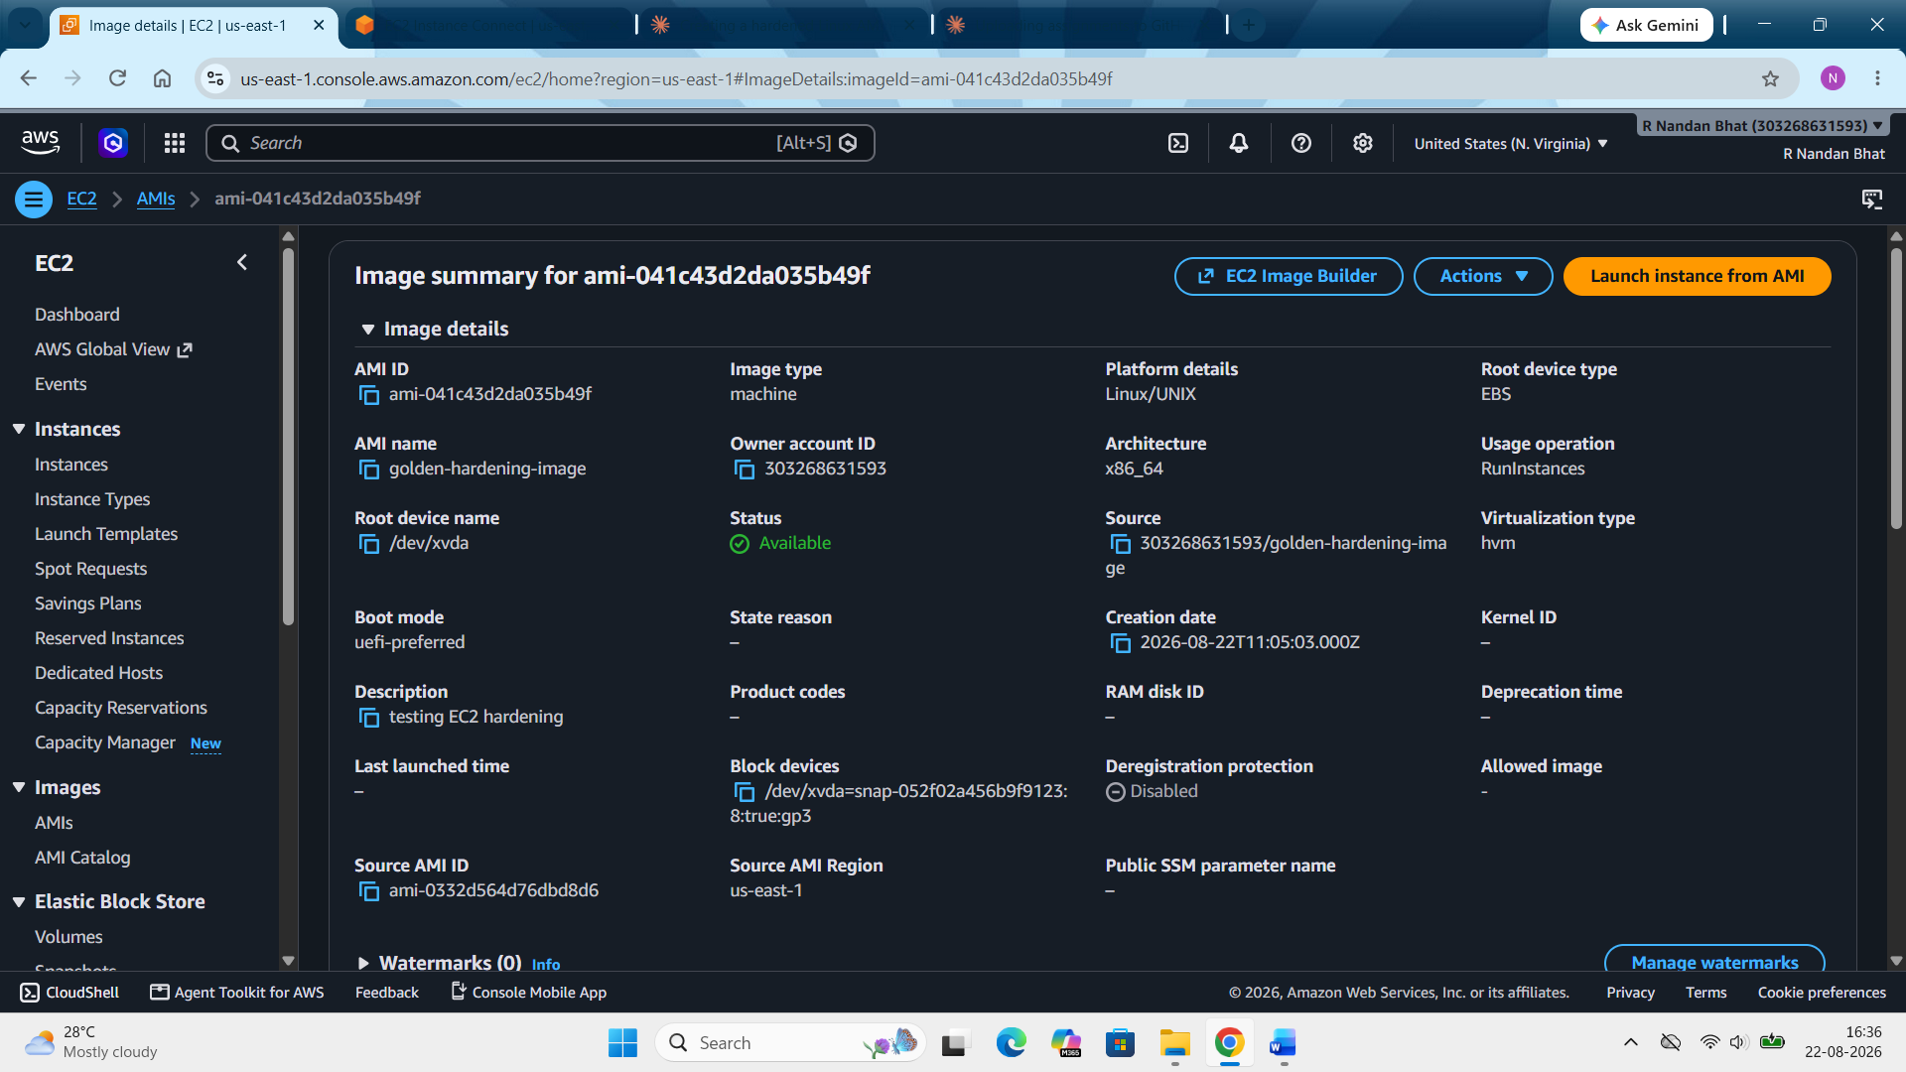

Step 6: Now we will test the hardening. For that we will launch a new server with the golden image and we will be able to see that it is already hardened. No need to repeat the script again.
For that go to EC2 images AMIs select the imgae launch instance from the image.
We can see most are already present. Just enter the name and select the same key pair as before.
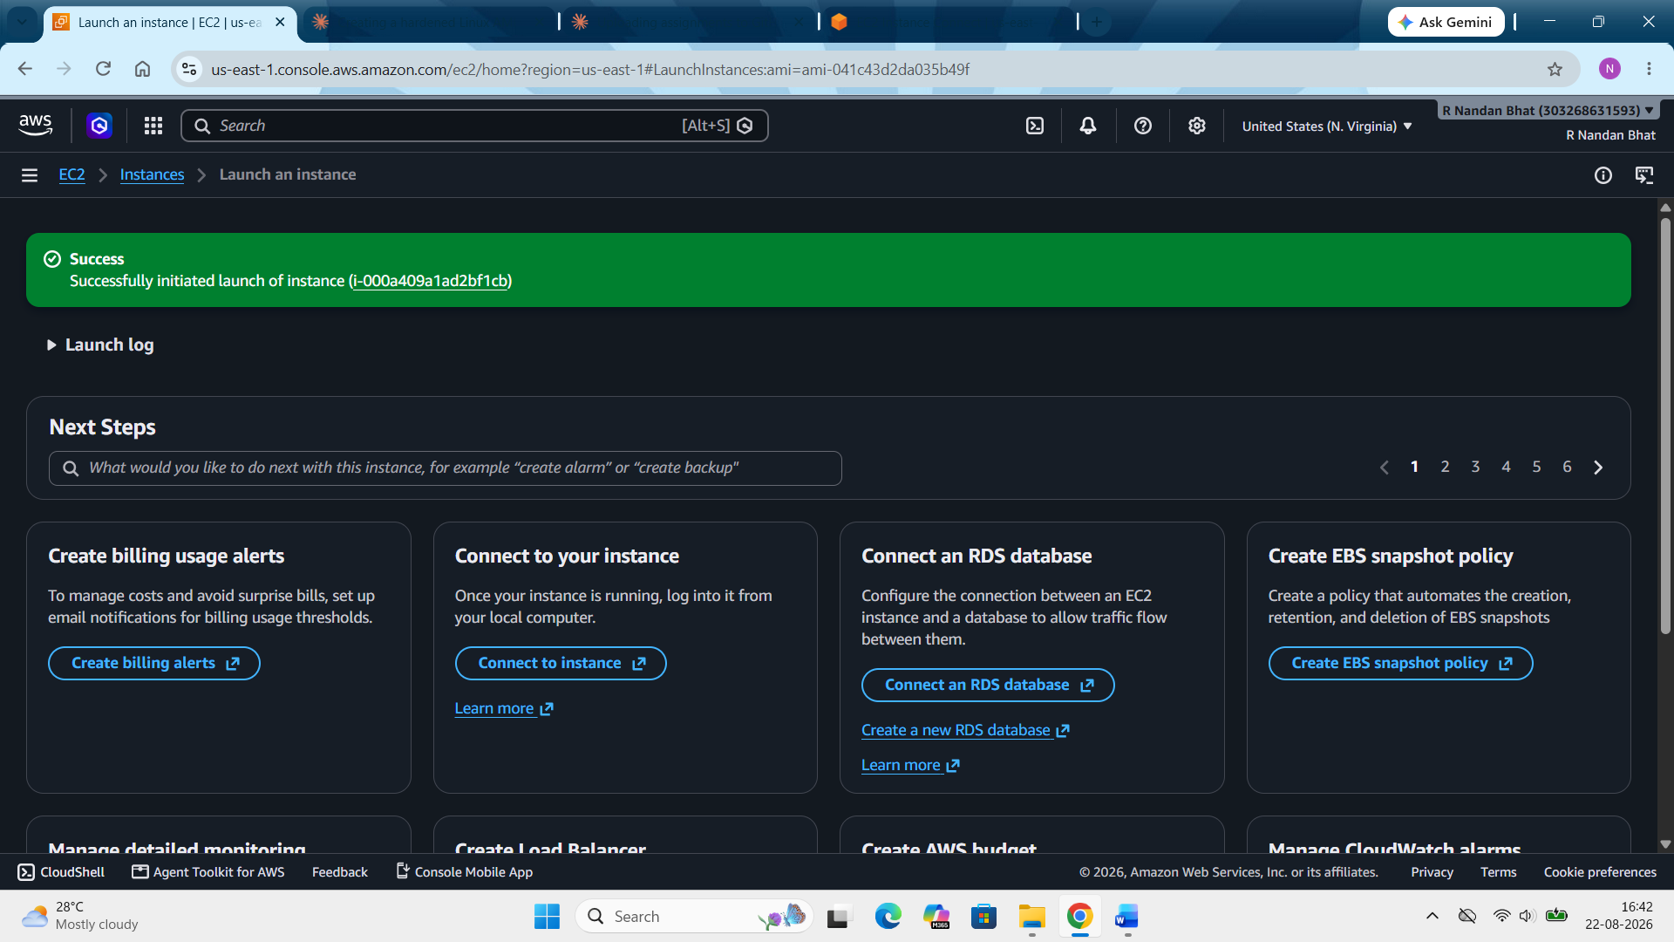
Now connect to the instance and run the following commands to verify if its hardened or not.
sudo systemctl status fail2ban
sudo sshd -T | grep permitrootlogin
sudo systemctl status auditd
Here change the user name from root to ec2-user. We have kept permit root login as ‘no’ in the previous instance.
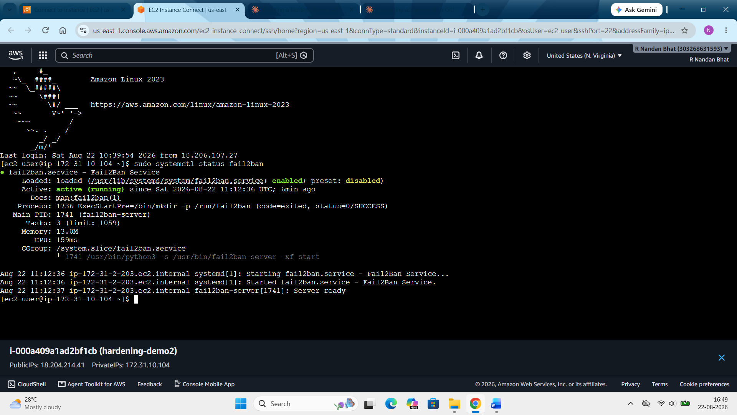
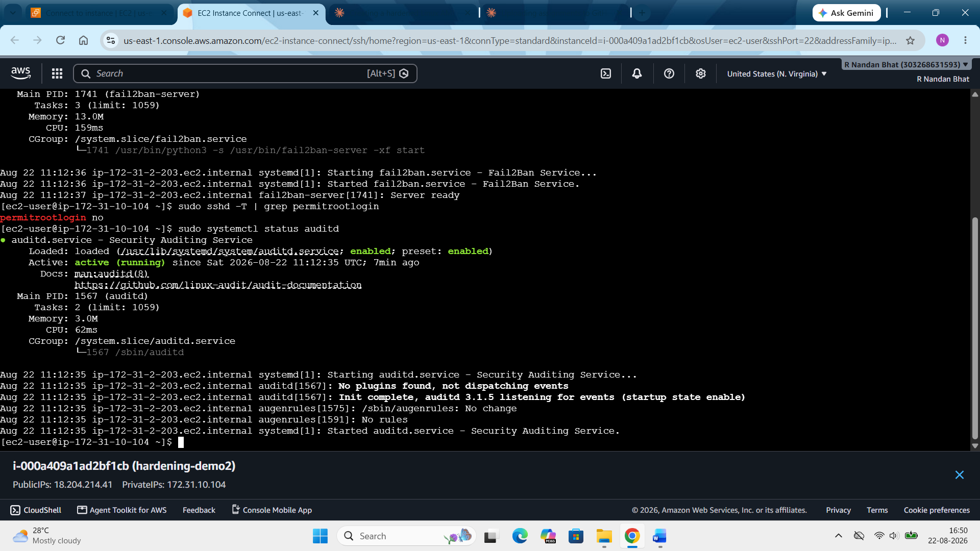
Here while verifying we can see that the status already shows runnind and active. This proves the golden hardening. This Golden AMI approach ensures that every new EC2 instance launched is automatically secure from the start, without needing to repeat the hardening process manually.

